VLSI Design

Electronics and Telecommunication, T.E. SEM VI

Experiment No : 4

Title : _______________________________
_______________________________
_______________________________
_______________________________

Date of Performance: ____________

Name of the Student:
SAP I.D No.:

Department of Electronics & Telecommunication Engineering

Experiment No.: 4 Date:

AIM:
To study the functional verification of multiplexer design using different styles.
- Static CMOS Logic
- Pass transmission logic
- Transmission Gate.

REQUIRMENT: Software LT Spice

THEORY:
- Static CMOS Logic: Static CMOS circuit implies that at every point in time except during switching transient, each gate output is connected to either Vdd or Vss via a low resistance path. A static CMOS gates consist of two networks pull up and pull down networks. Since n-MOS transistor produces strong zero, pull down networks, and consist of solely n-MOS transistor. The pull down network conditionally connects the output to ground. Similarly, p-MOS transistor passes strong 1’s, therefore pull up network contains only p-MOSFETs.

Y= (S+A).(S+B)

The above expression for 2:1Mux is in the inverting form, therefore PDN can be implemented by connecting n-MOS transistors in series whenever expression contain AND terms and transistor are connected in parallel whenever there is OR terms.

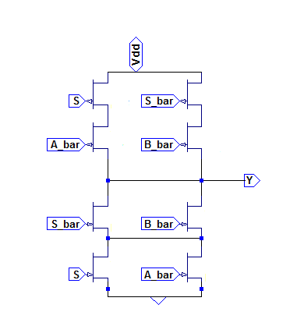
Fig a. 2:1 Mux using static CMOS logic
- Pass transistor Logic:
Pass transistor logic can be used to implement complex logic circuits. PTL utilizes n-MOS transistors only. The primary inputs drive the gate terminals and source-drain terminal unlike static CMOS logic where primary inputs drive the gate terminal.
2:1 Mux has 2 data input lines A and B, one control input line S and one output line ‘out’. when S=1then out=A and when S=0, out=B.
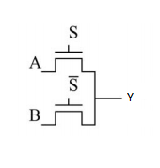
Fig c. 2:1 Mux using PTL logic.

- Transmission gate:

A 2:1Multiplexer can be implemented using transmission gates. A and B are the two inputs of the Mux. One of these input lines is activated and its value is transferred to the output line(Y) based on the value at select input line (S). When value of S is ‘0’ data at input line A appears at the output. On the other hand when value of S is ‘1’data at input line B appears at the output line Y.
When control input is low, the upper transmission gate becomes ‘ON’ while the lower switch is ‘OFF’. Therefore logic at A passes through the output 2. While when S is high, the lower switch becomes ‘ON’ allowing the voltage logic at B to appear at the output Y.
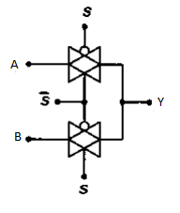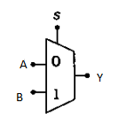

Fig b . 2:1 Mux using transmission gate

Procedure :

Part A: For 2:1 Mux using Static CMOS Logic
- Draw the 2:1 Mux using static CMOS logic
- Apply the pulse input to A, B and select input. Specify rise time , fall time, total time, T_{ON}, T_{OFF,} number of cycles.
- Observe the transient response of the circuit and verify the truth table.

Part B: For 2:1 Mux using Pass transistor Logic
- Draw the 2:1 Mux using Pass transistor Logic
- Set the threshold value for NMOS as 1V and -1V for PMOS.
- Apply the pulse input to A, B, and select input. Specify rise time, fall time , total time, T_{ON}, T_{OFF,} number of cycles.
- Observe the transient response of the circuit and verify the truth table.
Part C: For 2:1 Mux using Transmission gate
- Repeat the same procedure for 2:1 Mux using transmission gate.

Result and Discussion:

Conclusion:

